Don’t be like Billy Bully!
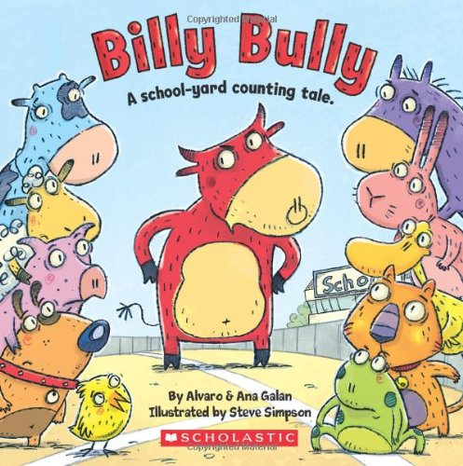

Draw a picture of when you were a good friend to someone!

*Listening, helping, and being kind to other kids*


Who can you talk to if someone is not being kind to you?
